PIPL Compliance for Log360 Cloud
Strengthen data protection and meet PIPL compliance with Log360.
Region: China | Type: Data Privacy, Incident Management | Category: Compliance | Pricing: Free

Overview
The PIPL compliance extension in Log360 helps organizations meet the Personal Information Protection Law of the People's Republic of China (2021), China's first national data privacy law issued by the NPC covering all personal information handlers by providing centralized log management, user access auditing, cross-border transfer monitoring, and threat detection. The platform supports PIPL requirements for consent management, sensitive data access controls, cross-border transfer oversight, security incident response, data subject rights, handler accountability, and audit trail compliance.
For Personal Information Collection and Consent Management, Log360 monitors all user access and logon activities across platforms, providing an audit trail that demonstrates authorized data access aligned with consent-based collection requirements. To address Sensitive Personal Information Access Controls, the platform tracks privileged account activity, Unix sudo commands, user group membership changes, and policy modifications to demonstrate controlled access to sensitive personal information. The extension also supports Data Security and Protection Measures by providing capabilities that audits file changes, removable media activity, registry modifications, and cloud storage events to enforce data security controls.

Key Features
- Cross-Border Data Transfer Controls: Log360 monitors network device policies, firewall rules, and traffic flows to detect unauthorized cross-border data movement and support transfer compliance documentation.
- Security Incident Detection and Breach Notification: Log360 provides threat detection, malware alerting, and security event correlation across Windows, Unix, and network infrastructure to enable rapid identification and response to data breaches.
- Personal Information Collection and Consent Management: Log360 monitors all user access and logon activities across platforms, providing an audit trail that demonstrates authorized data access aligned with consent-based collection requirements.
- Sensitive Personal Information Access Controls: Log360 tracks privileged account activity, Unix sudo commands, user group membership changes, and policy modifications to demonstrate controlled access to sensitive personal information.

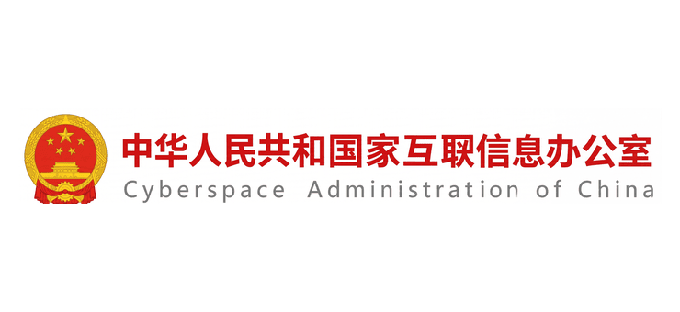
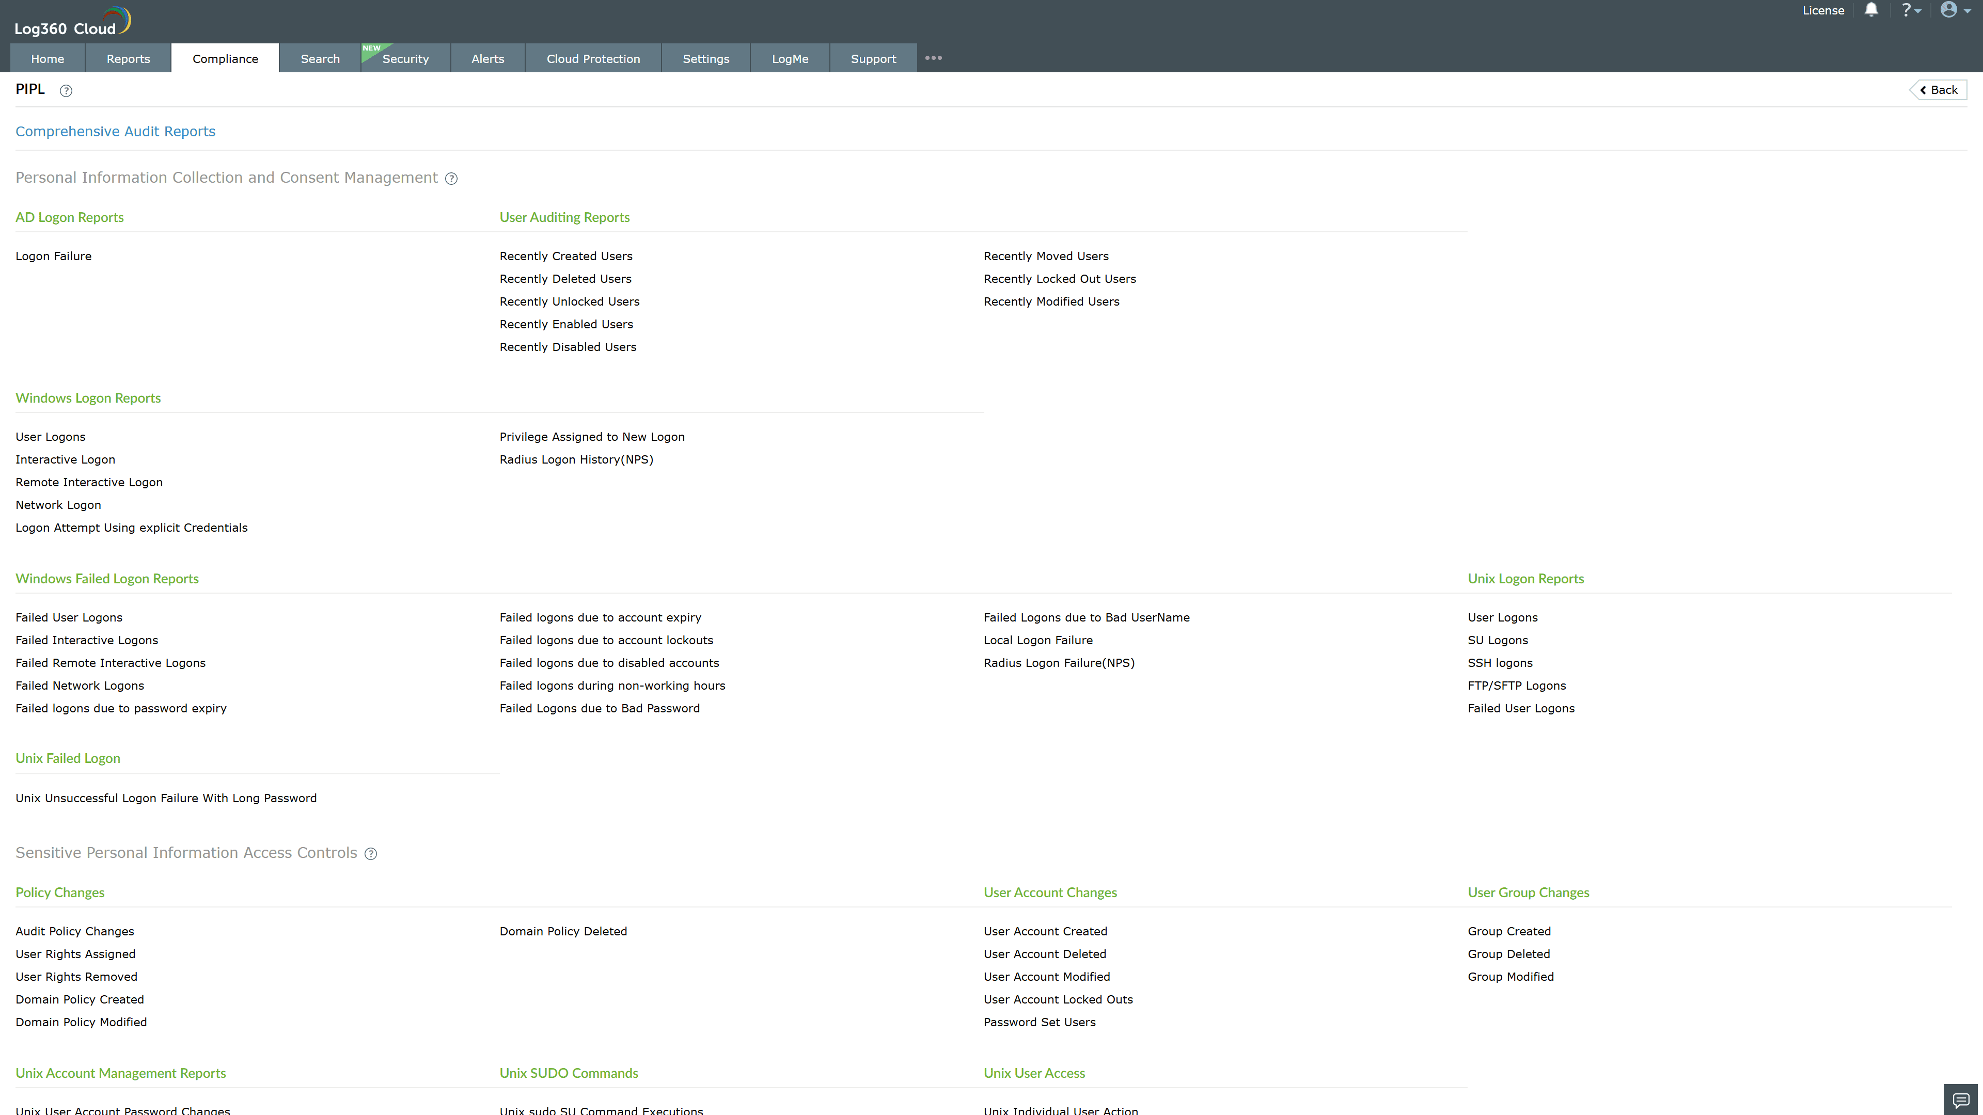
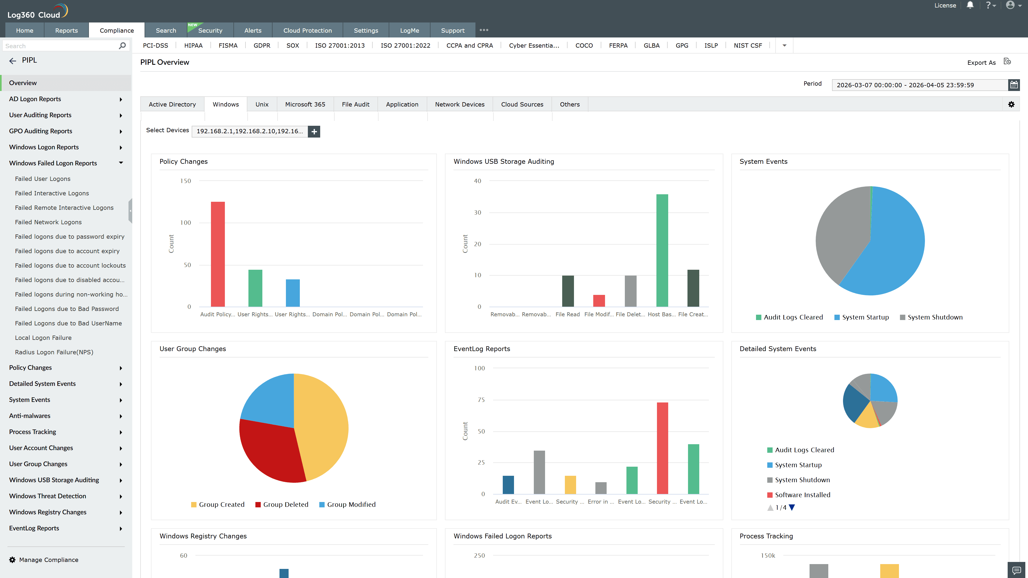
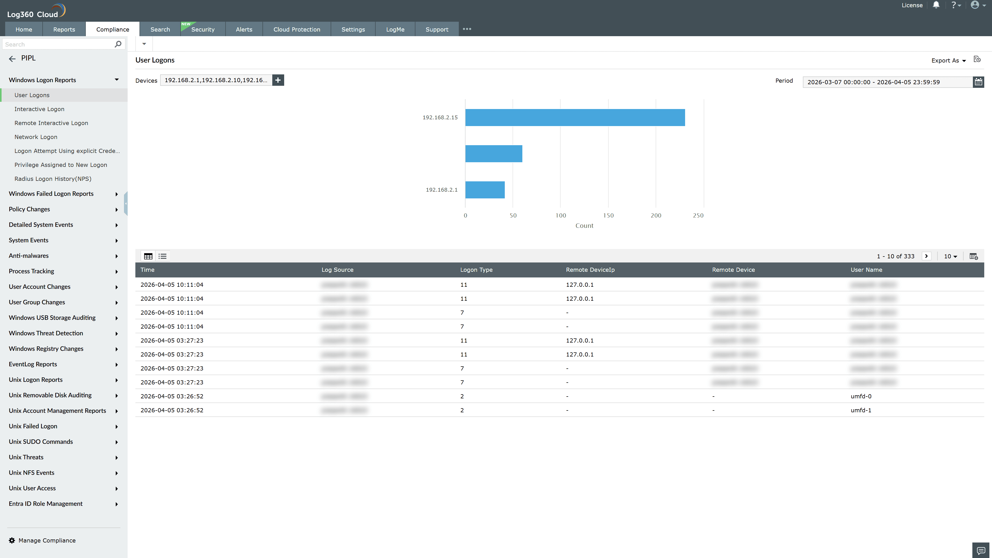
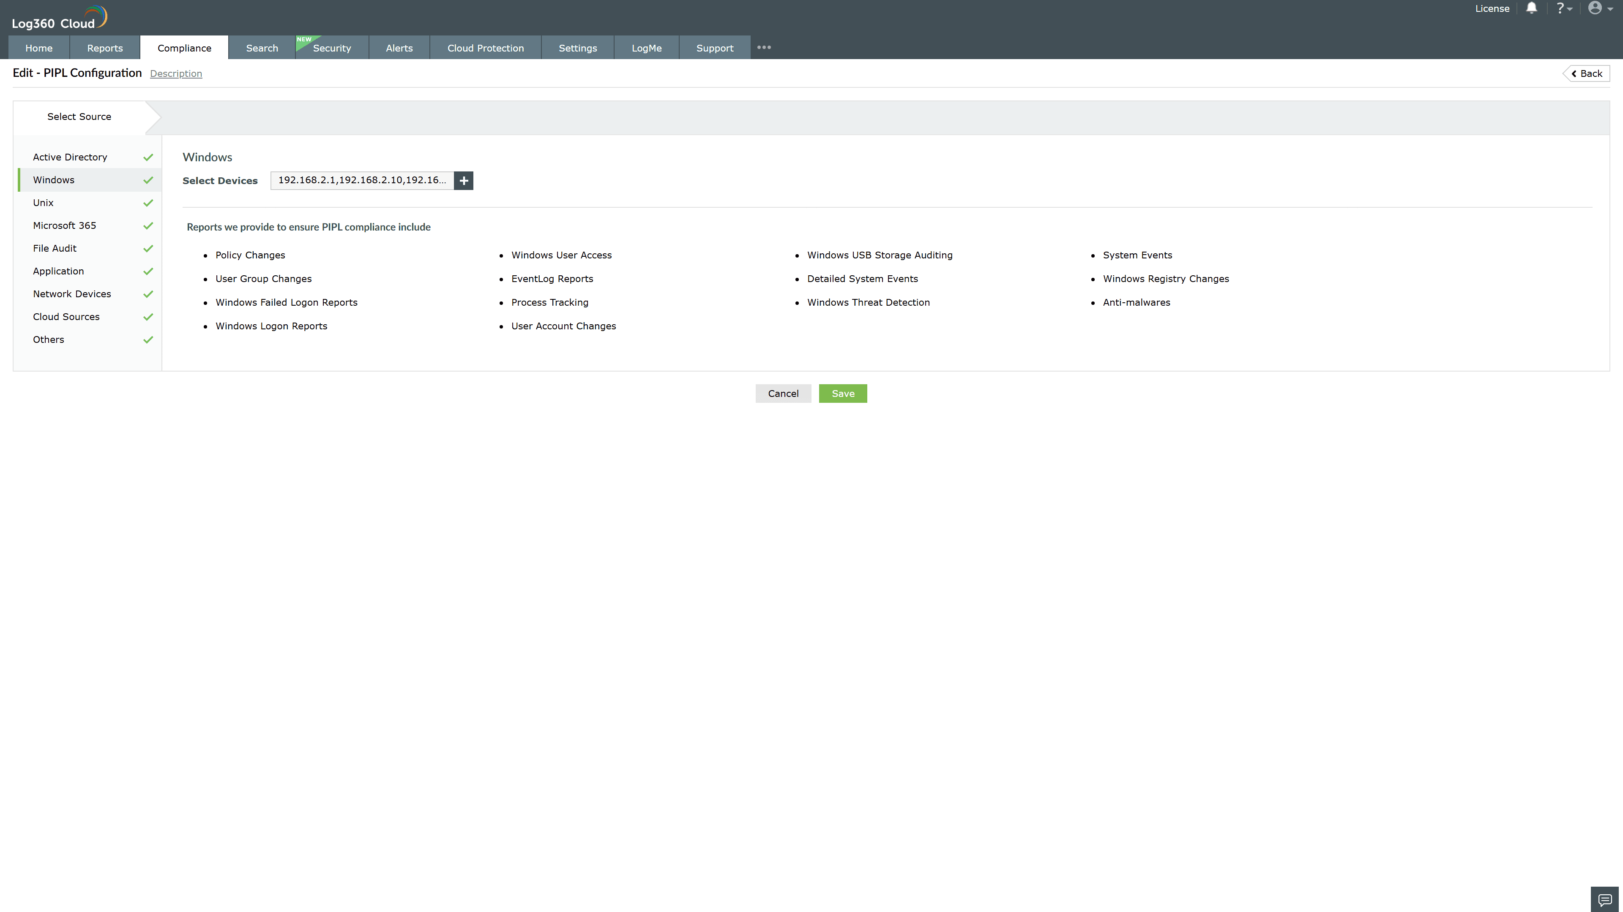
Valid Submission : Yes
Supported Editions : Free, Basic, Standard, Professional, MSSP
Help Document : https://www.manageengine.com/log-management/help/integrations/compliance-extensions.html
Help Video : Not provided
Tags : Log360 Cloud, Compliance, Privacy monitoring, Data privacy, Regulatory compliance
Supported DCs : US, IN, JP, CA, AU, UK and EU
Privacy Policy:
Terms of Service:
Release Notes:
Predefined reports for the PIPL.

